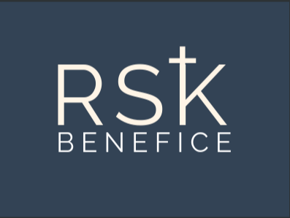

The Benefice of Radley, Sunningwell, and Kennington has a part-time vacancy for a Parish Administrator.

The post requires a variety of administrative skills to provide support for the three Parish churches, clergy team and lay church officers.

The post is for 10 hours per week, to be worked flexibly between Monday - Friday. Salary £11.44 per hour.

Please contact the Rector for more information
Telephone 01235 554739.
Email robertglenny@gmail.com

To apply visit rskbenefice.org/parish-admin
for further details.

Closing Date for applications: Friday 17th May 2024
Interviews: Tuesday 21st May

